**Lab Test Module**

1. **Test booking:**

**Book new test:**

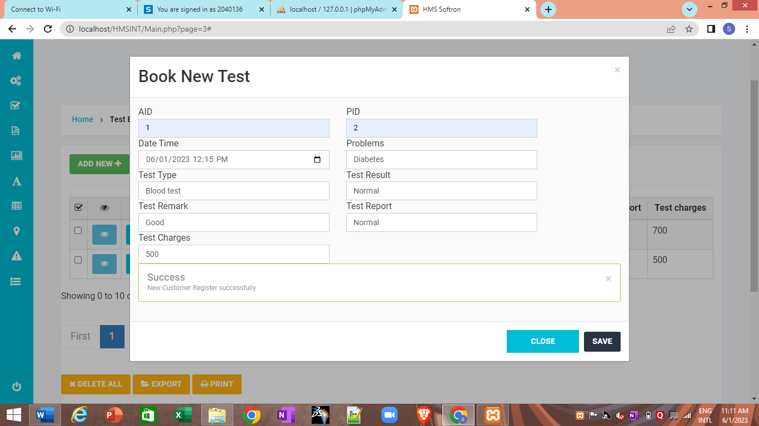

**View Test details:**

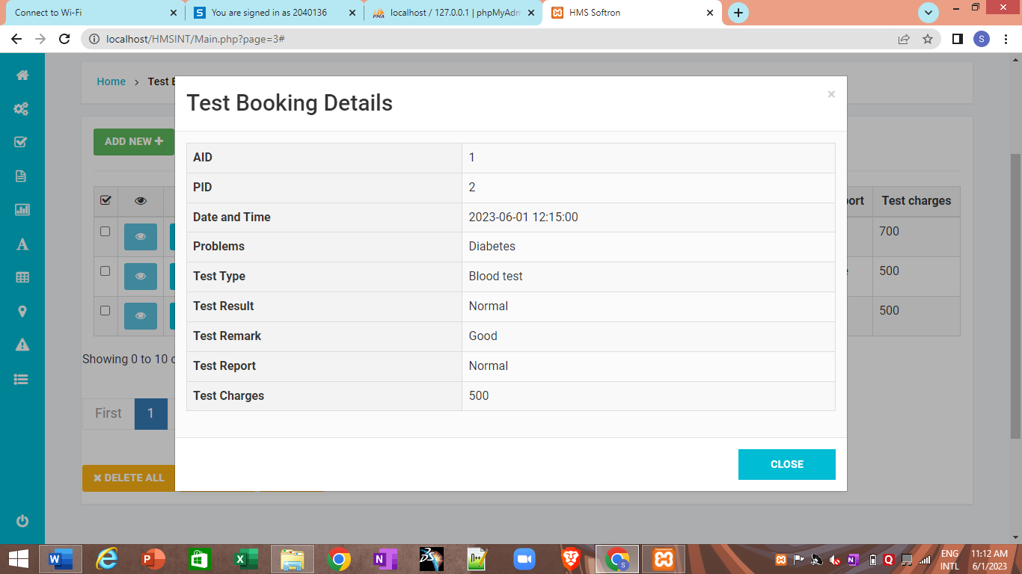

1. **Blood Donation section:**

**Add donor details:**

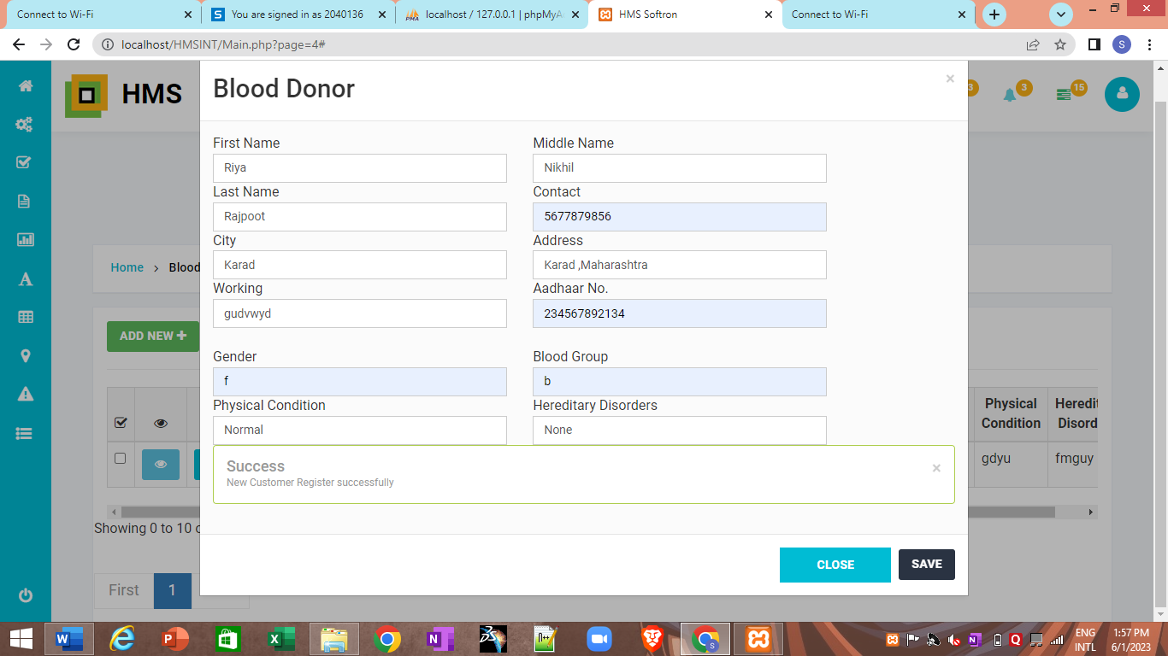

**Modify donor details:**

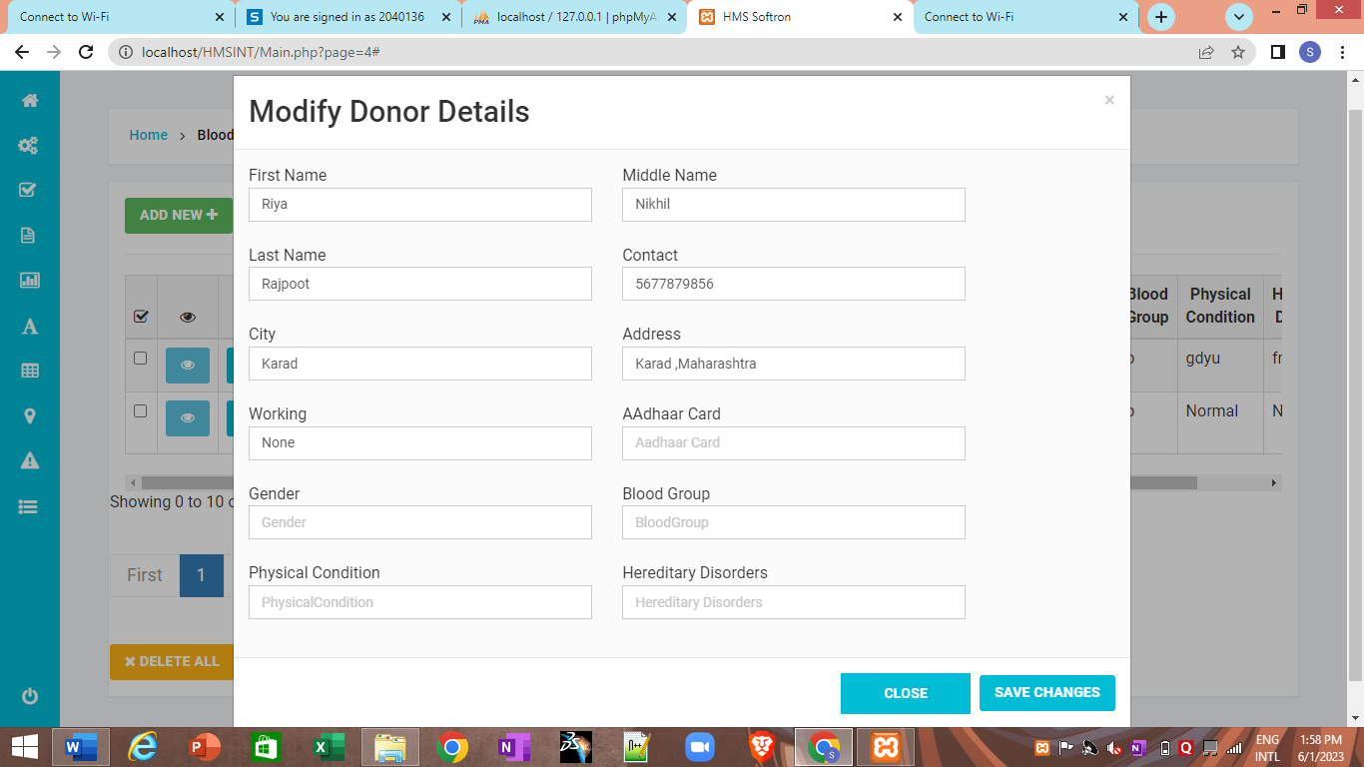

**Print donor details:**

